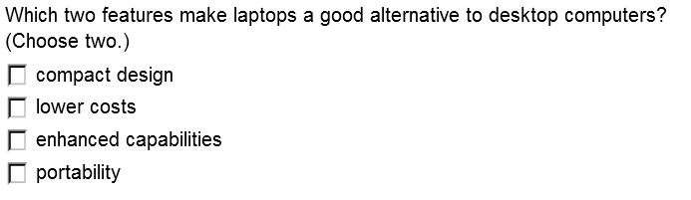1

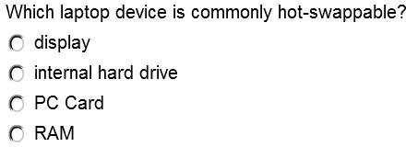

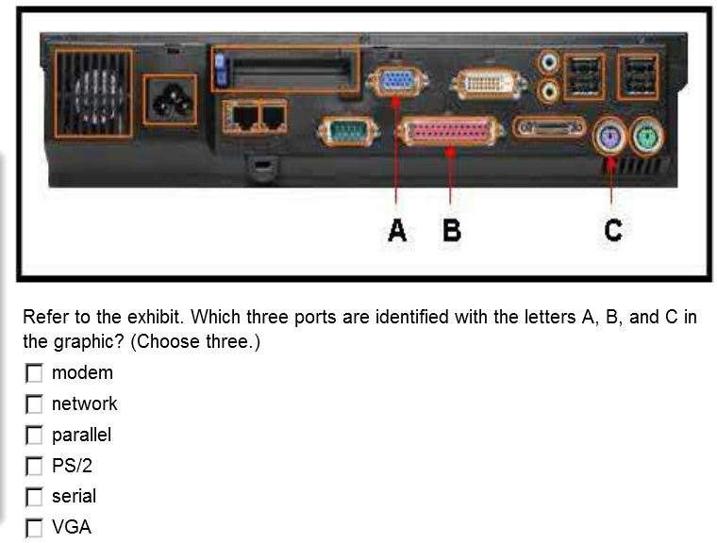

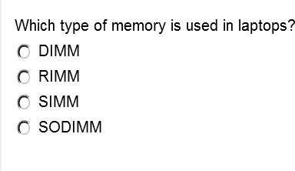

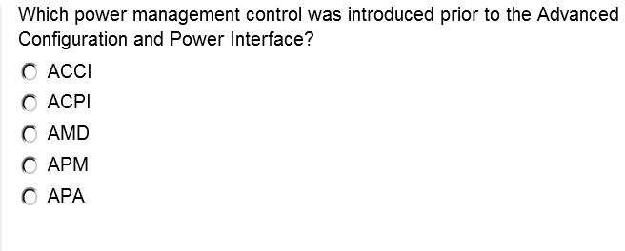

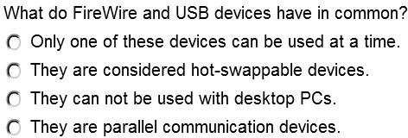

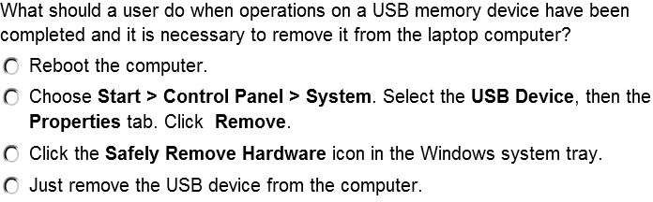

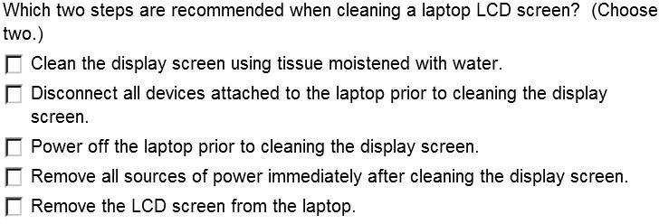

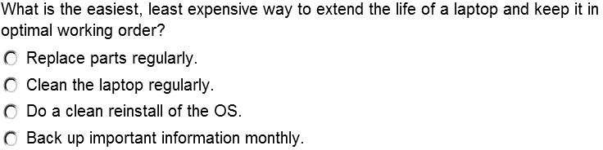

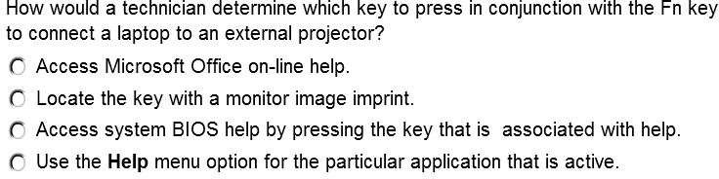

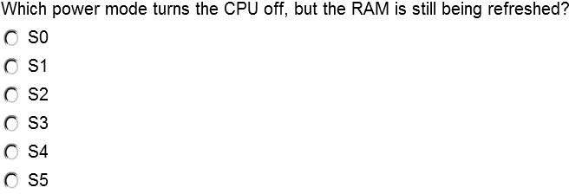

What windows 10 laptop power plan saves open documents and applications to a temporary file on the hard drive, with the result that it takes longer to bring the computer back to a usable condition?

* Deep Hibernation
* Hibernate
* Hybrid Sleep
* Sleep

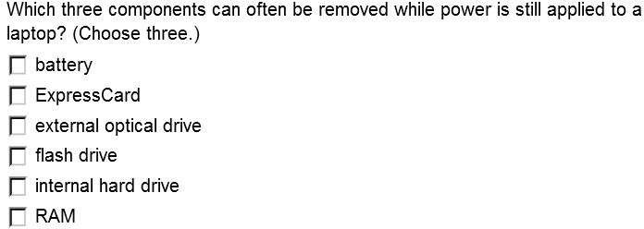

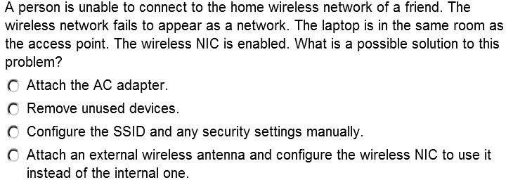

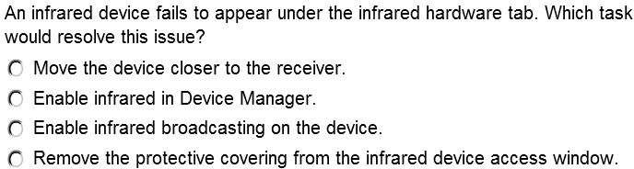

A newer type of PC card is called the ……………………………..

* 1. Express Card
  2. PC card disk
  3. PC card Bus
  4. PCMCIA card

The PC Express card has ………. And ……….pin configuration.

1. 64 and 128
2. 32 and 54
3. 28 and 40
4. 9 and 15

When you are ready to clean a laptop’s LCD, which of the following would you select?

1. Trichloroethane solvent
2. Ammonia-based solvent
3. Window cleaning solvent
4. Isopropyl alcohol and water

* Which of the following is the port replicator, as well as adds more functionality with additional drives?
* USB hub
* Docking station
* Drive bay
* Storage area

